**Assignment no 4:** Building a war file on one ec2 machine and deploying and hosting on another ec2 Linux server.

Created Jenkins master server on which I have already installed maven and created a Jenkins job to generate war file. After war file is created, I’ve successfully copied that file on another ec2 machines Apache tomcat server.

Machine 1- Jenkins master with maven installed & Machine 2 have Apache tomcat server installed.

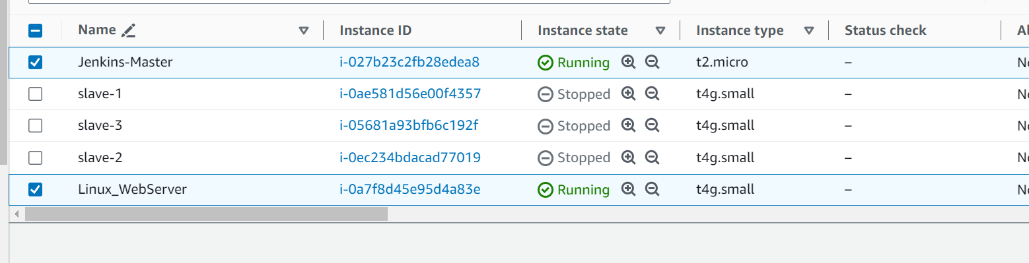

Created a job with Jenkins for maven and war build on Jenkins master, with below configuration:

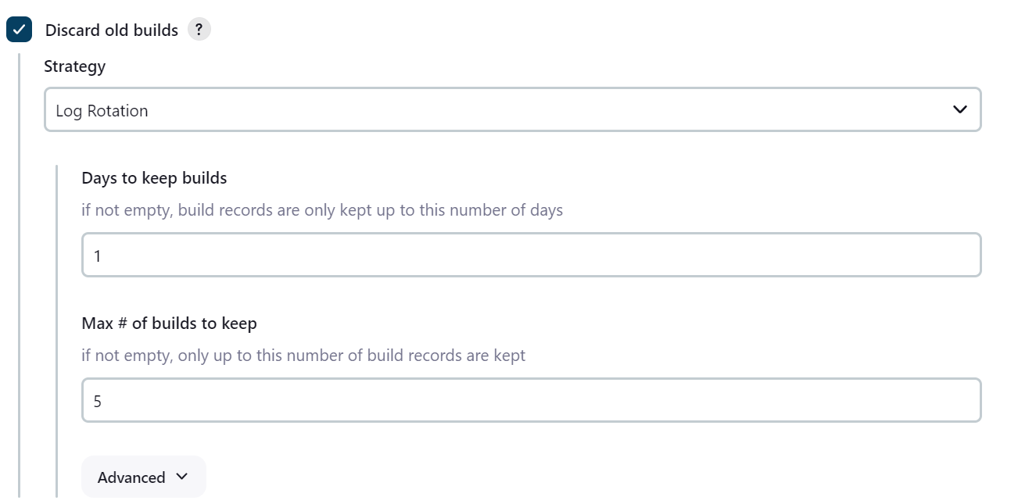

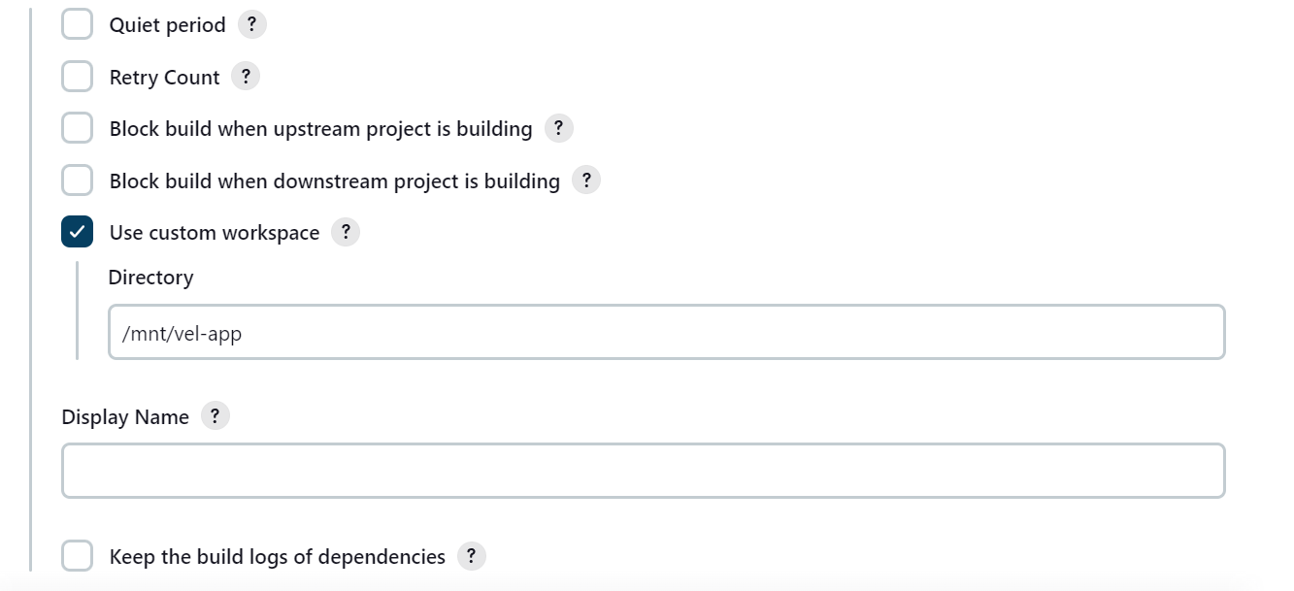

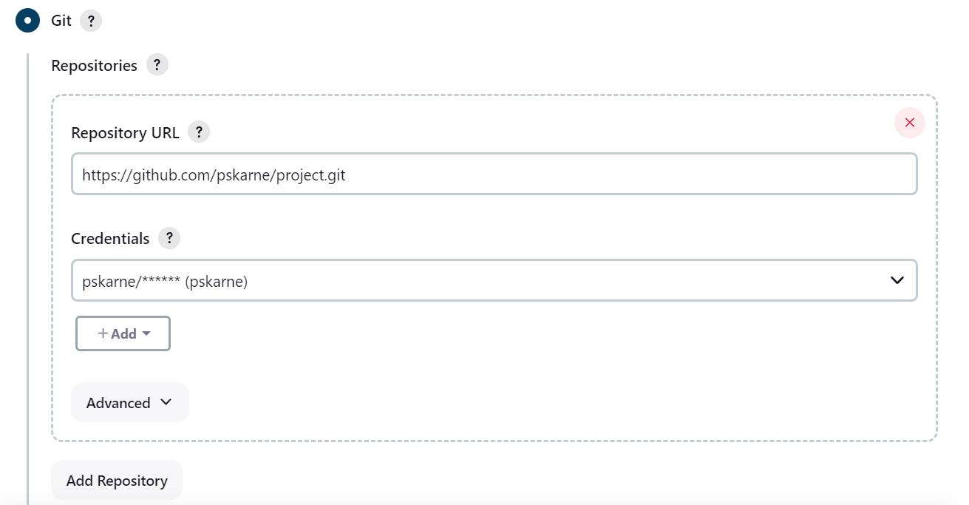

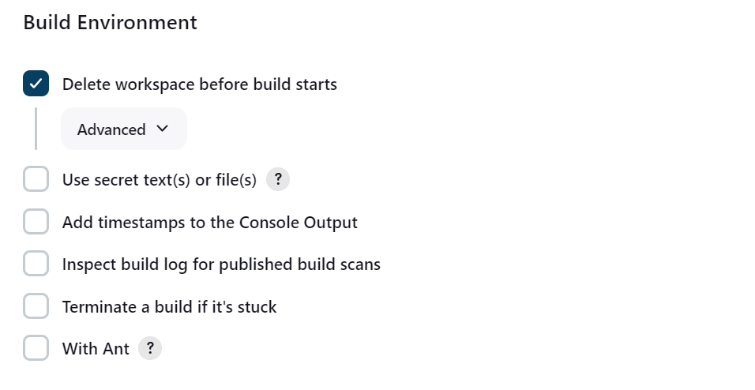

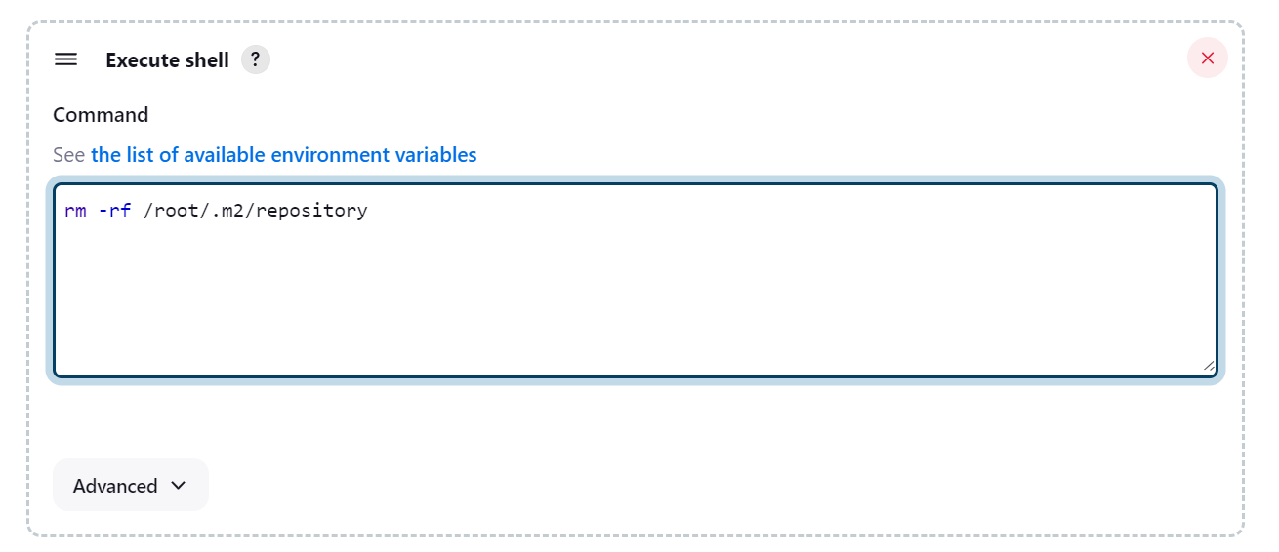

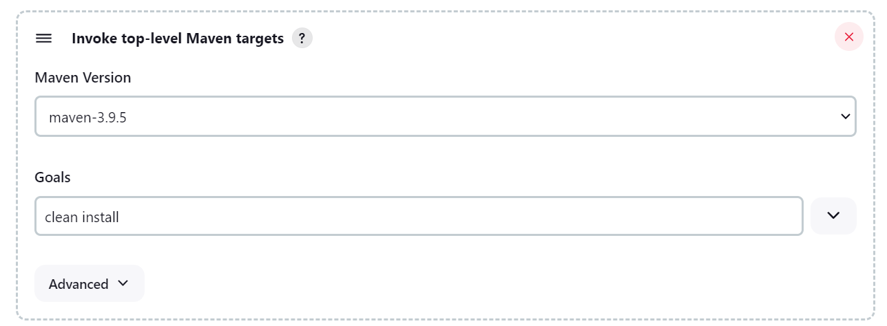

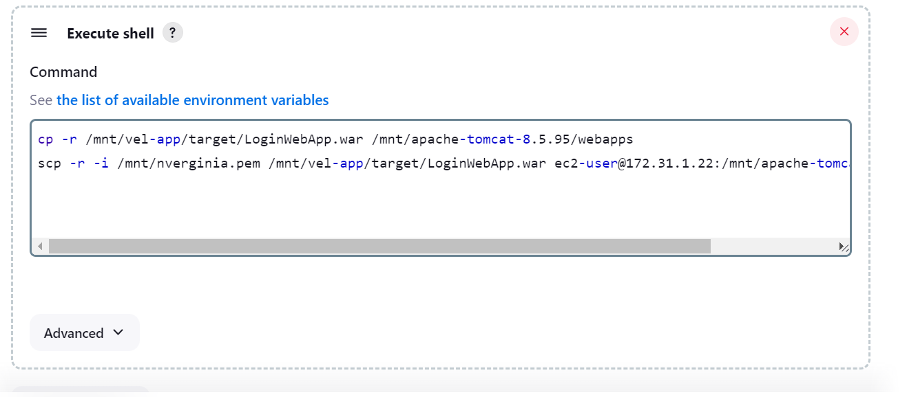

War file has been successfully generated on master server:

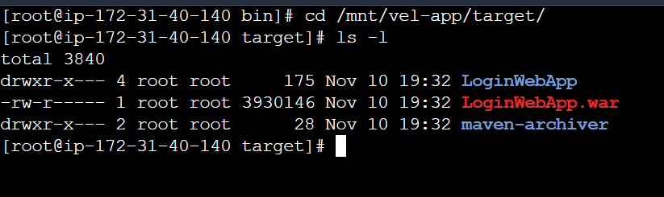

With the SCP command the war file is copied on server 2’s inside Apache tomcats webapps directory:

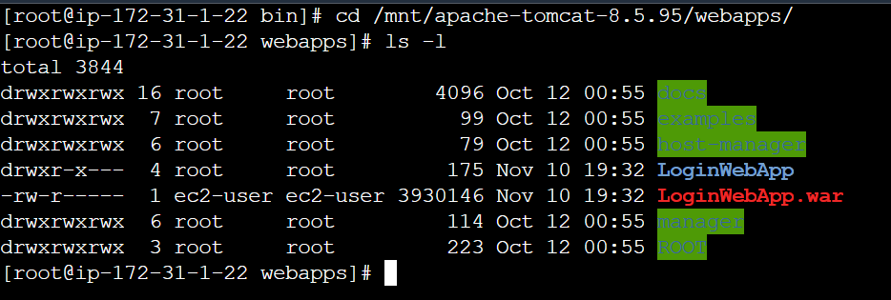

I can also see that LoginWebApp is accessible through the browser:

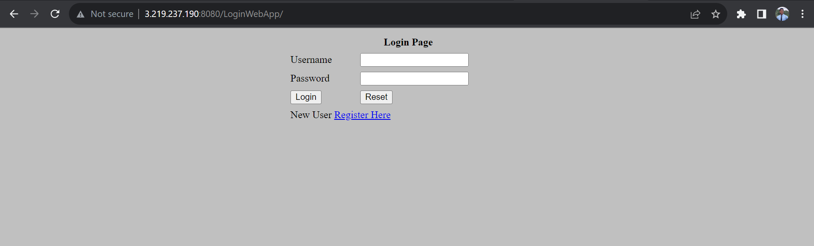

**Successfully completed assignment 4**